The AAR of a SALT visit to Manamalai Panchayat in Tiruvannamalai, Tamil Nadu, India
Wednesday 21 November 2012
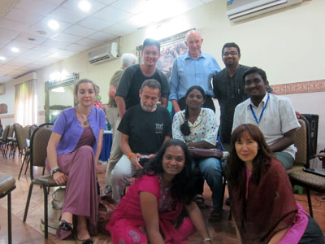
Taejha, Luc, Samarkun, Jason, Thiviya, Kumar, Phil, Gunavathi, Sujatha, Jessica, Sirinate and Caroline visited Manamalai Panchayat in Tiruvannamalai, Tamil Nadu, India

After Action Reflection
Summary
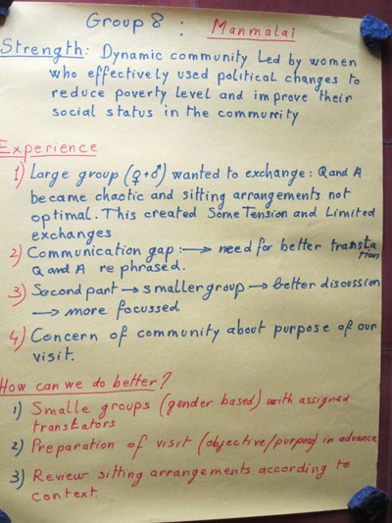
Strength
We found a dynamic community led by women who effectively used political changes to reduce poverty levels and to improve their social status in the community.
Our experiences
- A large group of men and women wanted to exchange. Those exchanges became chaotic and sitting arrangements were not optimal. This created some tension and resulted in limited exchanges.
- There was a communications gap. We needed to find better ways to translate the exchanges. We need to find ways to rephrase the questions and the answers.
- In the second part of the SALT visit, we reorganised ourselves into a smaller group. This led to a better discussion that was more focused.
- There was a concern of the community about the purpose of our visit.
How can we do better?
- Organise ourselves into smaller groups (gender based) with assigned translators.
- Prepare visit in advance (objective/purpose).
- Review sitting arrangements according to context.

Details
Strengths
- We found a dynamic community making rapid progress.
- The community had created a large number of groups (26) that was dealing with a wide variety of issues.
- The community has gained political status and this has given them significant economic gains (that you can see).
- The women are strong. Women have taken advantage of increased prosperity to gain financial levers in the community. This had led to an increase in the social status of the women and a reduction in gender-based violence.
Experiences and lessons
During the SALT visit, the community was puzzled about why we were there.
- If visit organisers make it clearer why we are coming, then the problem will be reduced.
- If we prepare an explanation before we go, translate it carefully before we go and use it as part of the welcome and introduction, then the problem will be reduced.
When we arranged ourselves on mats as 2 groups in a circle, it created a sense of US and THEM and it gave the visit the feeling of an interview.
- If we arrange ourselves randomly in a circle, this will help to create the feeling of a conversation.
(BUT some members of group were concerned that this arrangement would create problems with social norms. There was a suggestion that we could deal with this by using chairs.)

Throughout the SALT visit, there was a 'communication gap' with the challenge of translation.
- If we think carefully about translation resources before the visit, we can reduce the 'communication gap'.

During the first half of the SALT visit, a large group of men and women made the visit noisy and chaotic. In the second half, we were with a smaller group of women and there was more engagement and order.
- If we can have a SALT visit with a smaller group, the problem will reduce

